Brainstorm & Idea Prioritization 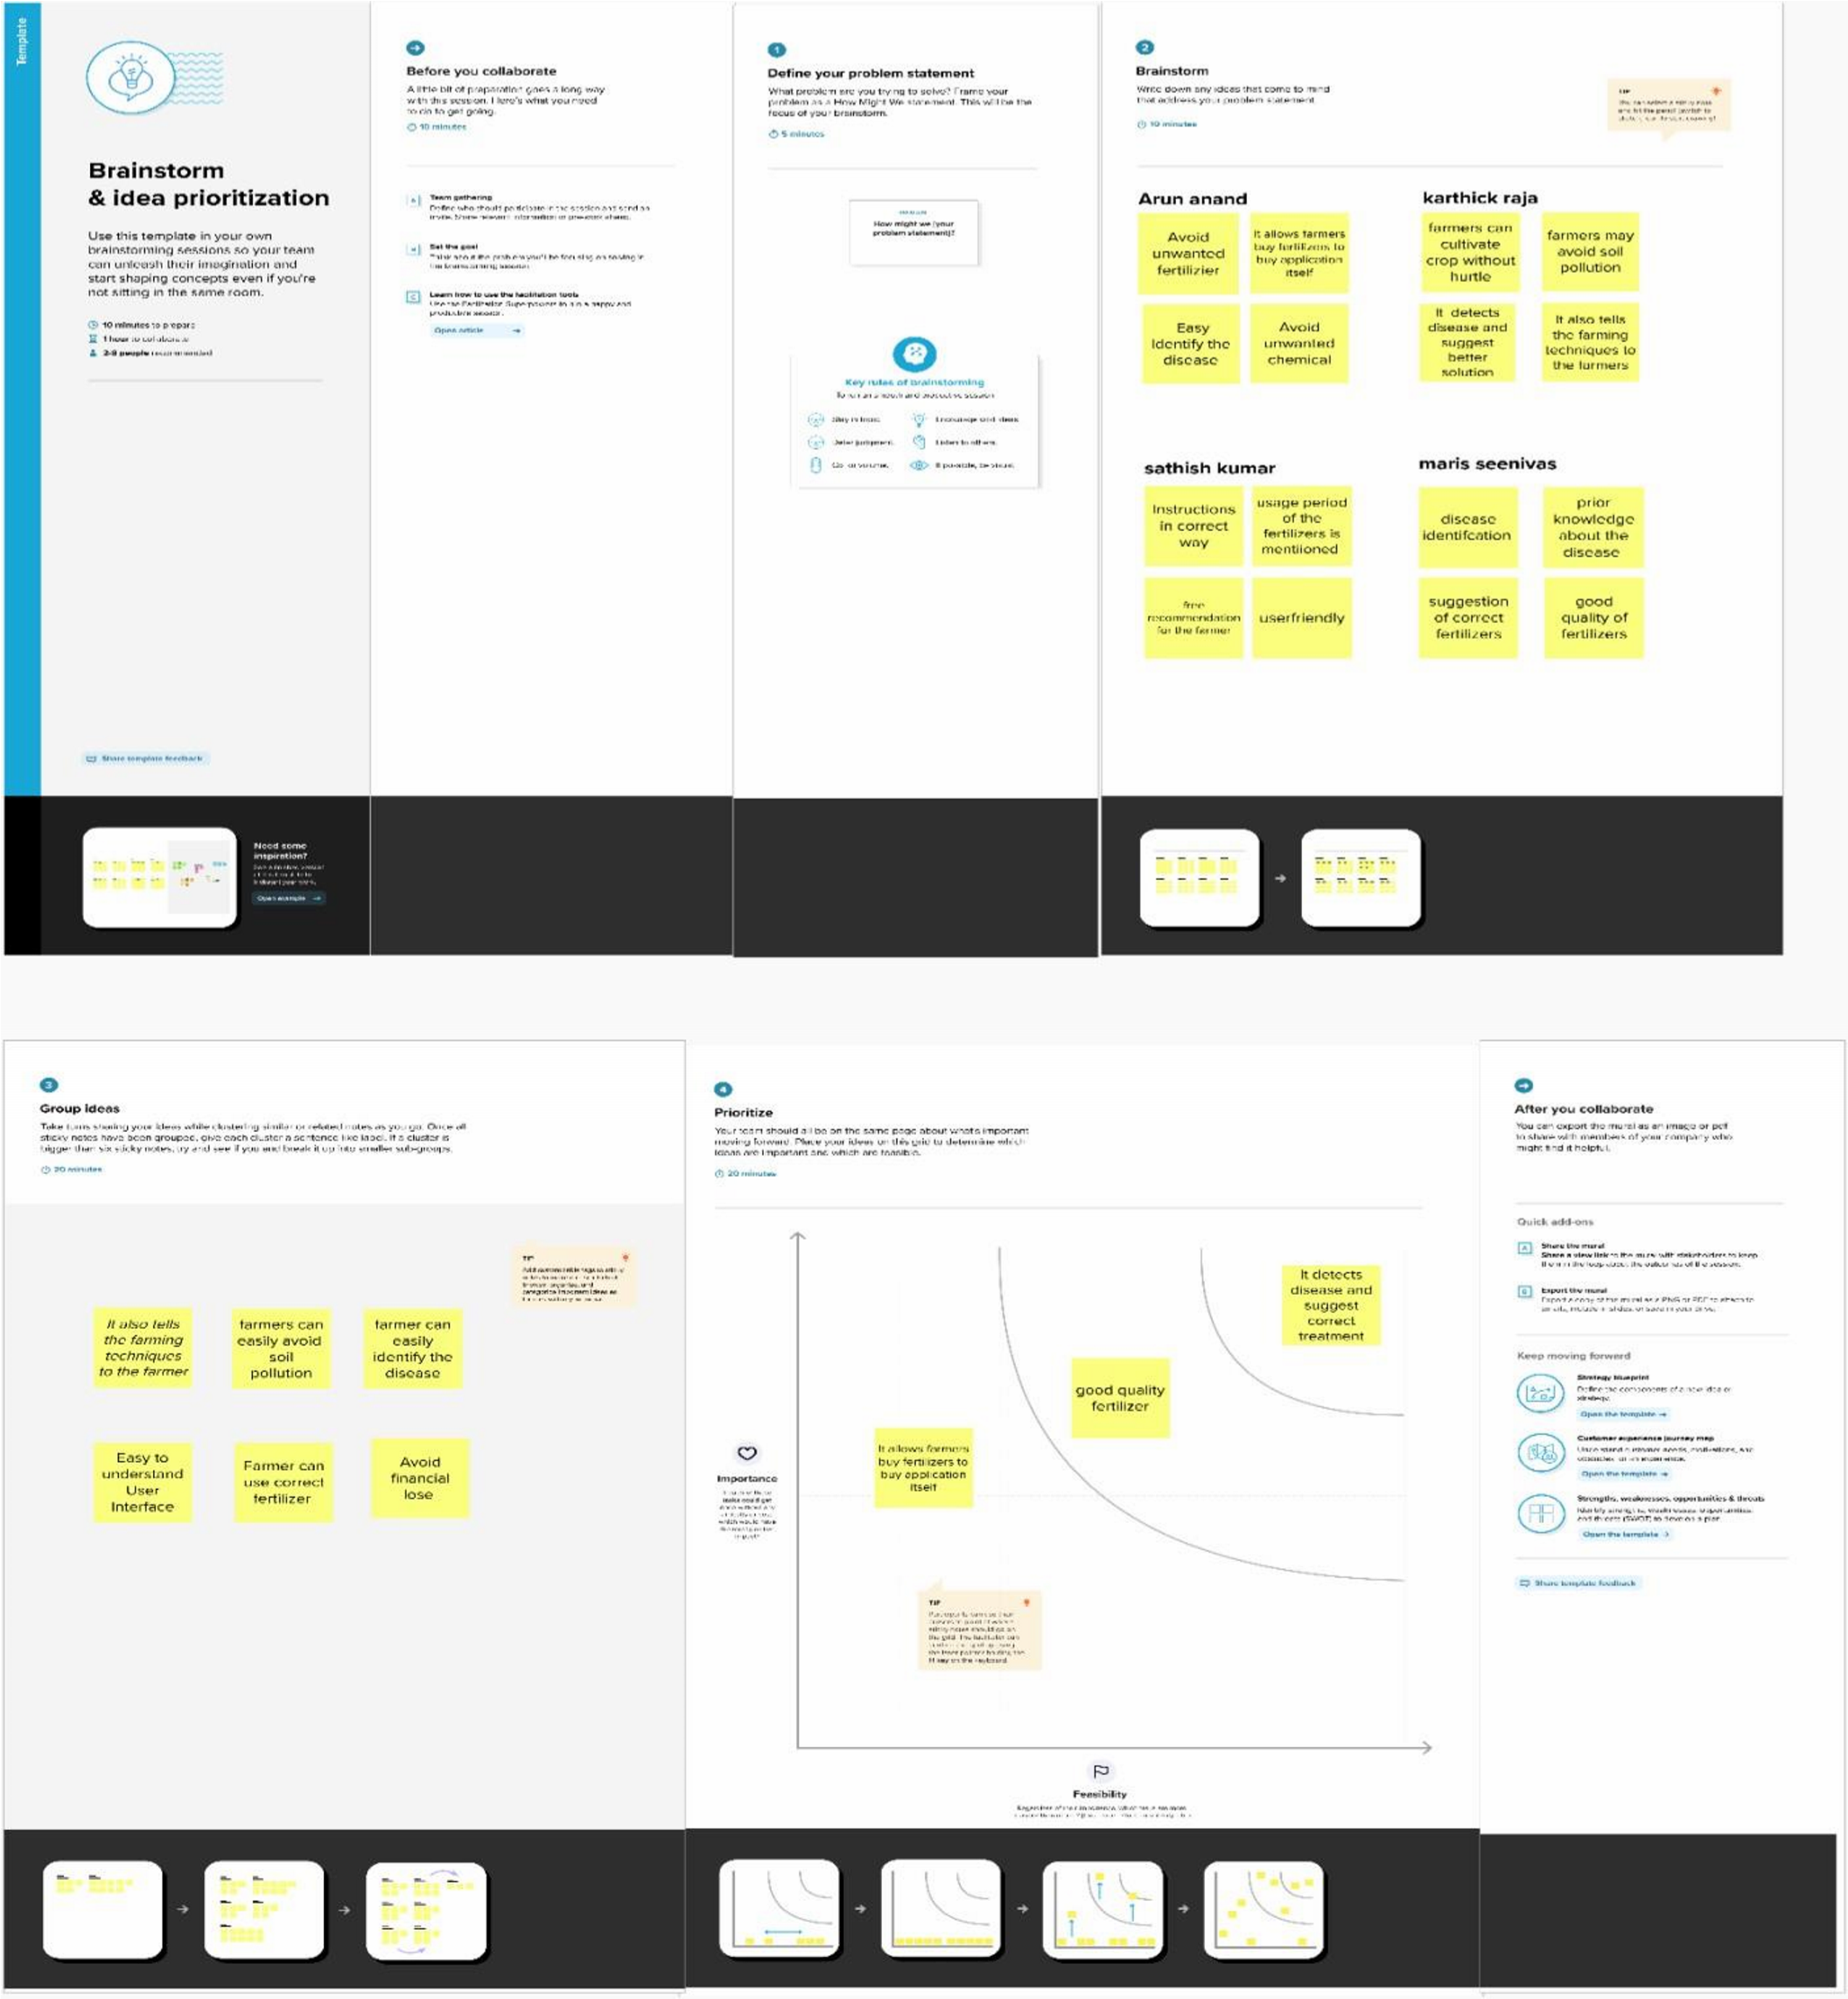

|  |  |
| --- | --- |
| Team id | PNT2022TMID12064 |
| Project name | Fertilizer recommendation system for disease prediction |
| Maximum marks | 4 marks |